Syncing OneHE badges with Badgr

Before you begin syncing badges earned through OneHE, you must first create a Badgr account.
- Create your account by visiting the Badgr login page.
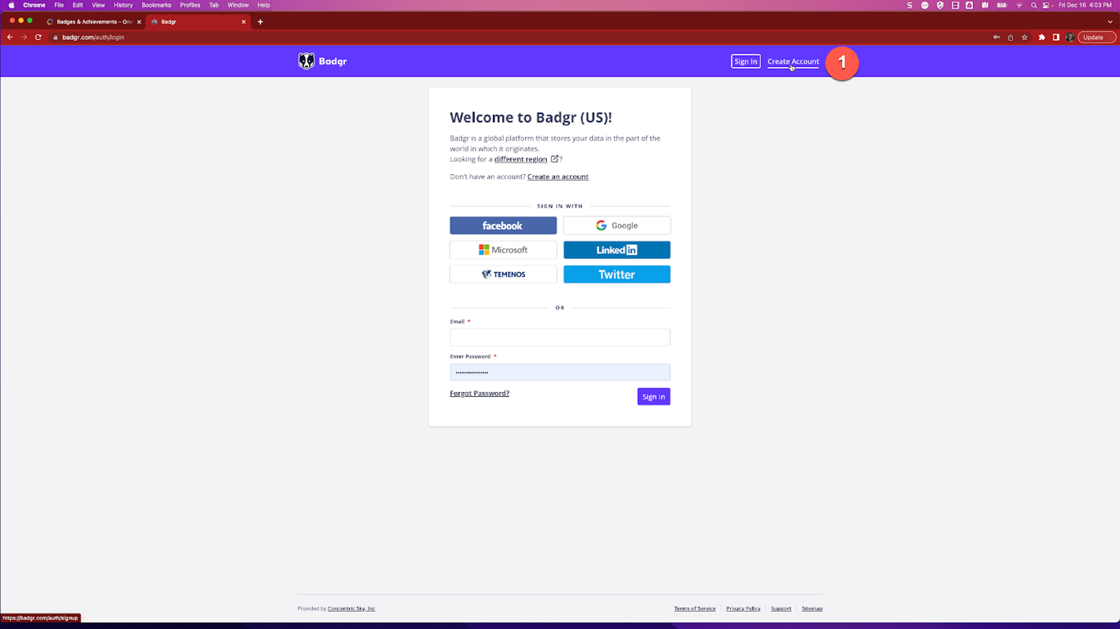

Once you have created a Badgr account you are ready to sync with OneHE.
- Log in to OneHE.
- Navigate to the Courses and Resources menu at the top of the screen and click on Badges and Achievements.
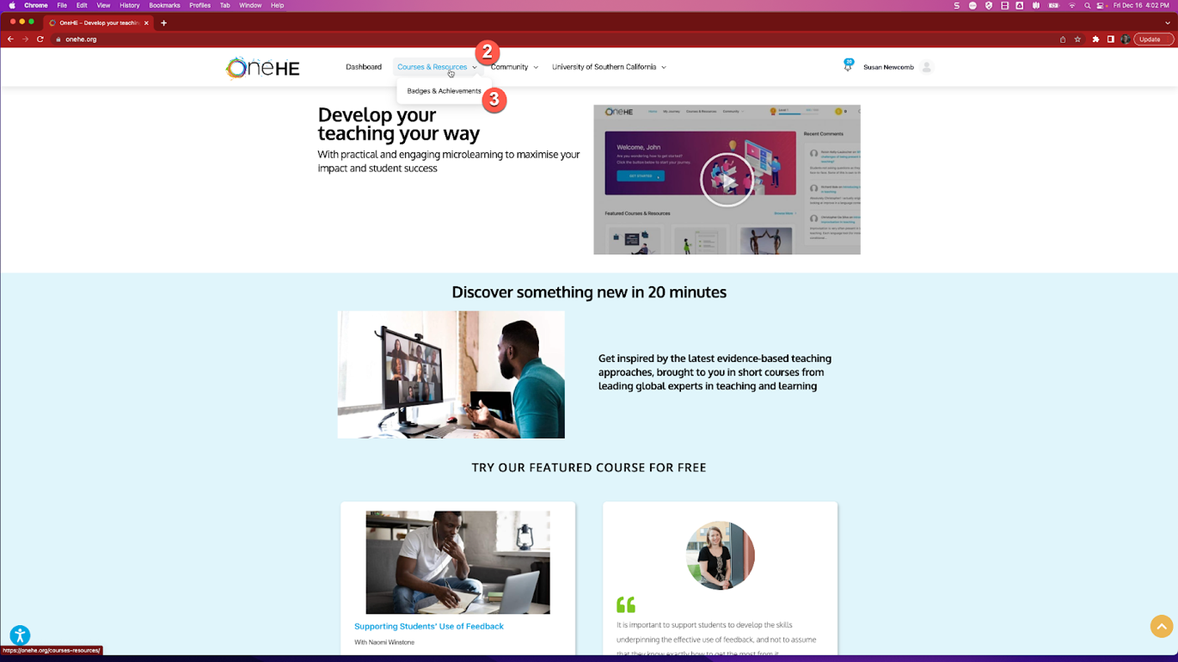
- Scroll down to the bottom of the page and look for the text “Sync with Badgr”.
- Enter the email and password associated with your Badgr account and click “sync”.
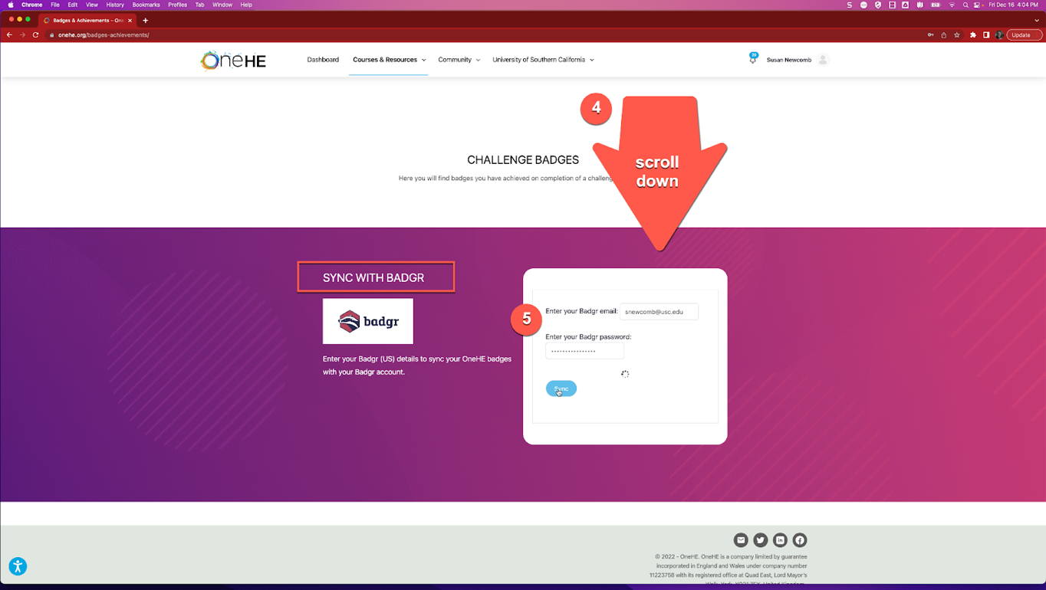
Congratulations! Your OneHE account is now synced with Badgr and you can begin earning digital certificates and badges!

