Claiming your digital badge and certificate
When you receive an email from Badgr, notifying you that you’ve earned a badge, you’re given the options to download the badge image and create an account with Badgr. While downloading the badge directly has some benefits, creating an account opens up the full range of possibilities so you can make the most of your digital achievement.
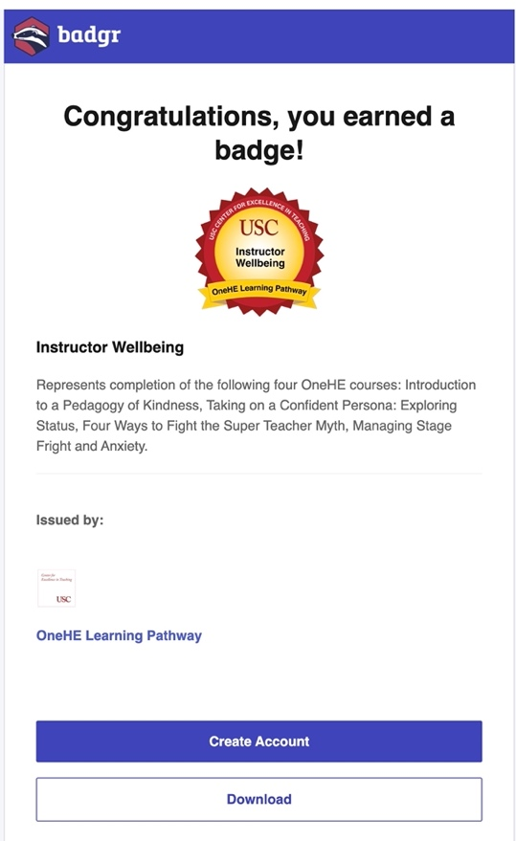

Once you’ve selected Create Account, you’ll be sent to a CET landing page.
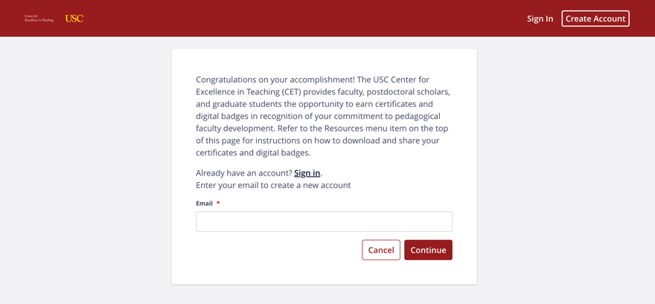
On your first visit, create an account by entering your email address. If you have previously created an account, select the Sign In link.
A verification code will be emailed to the address you provide. Once you’ve entered the verification code, continue to complete the signup process on the next page.
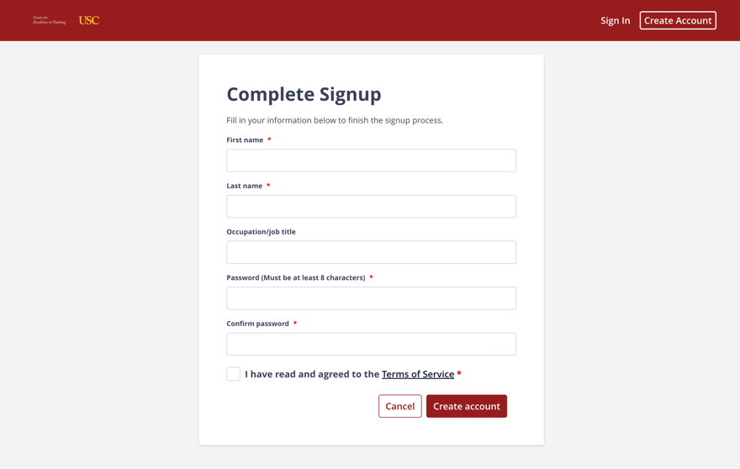
To complete the signup process, enter your first and last name, create a password and confirm, agree to the terms of service, and then select Create account.
Now you have access to your Badgr backpack, you can view the badge you just earned as well as previously earned badges.
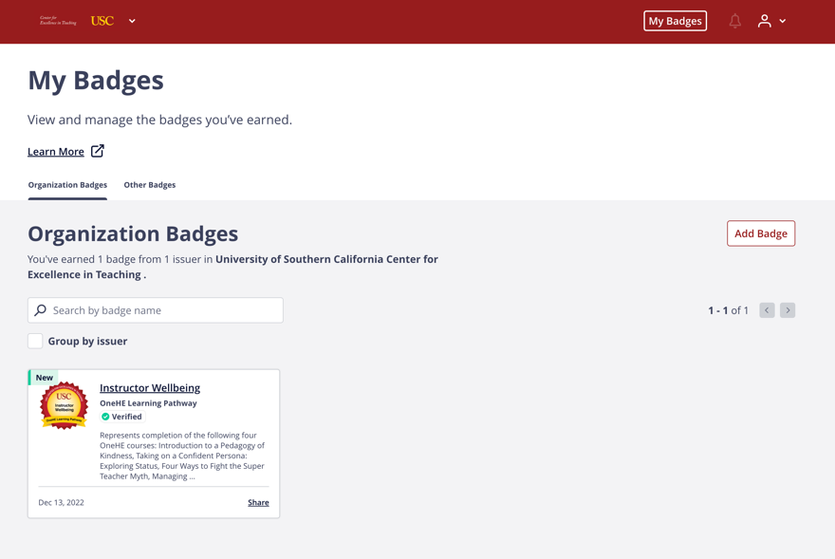

Select a badge to view from your backpack. The page that opens will include all of the data associated with your badge, including the image, title, description, and earning criteria.
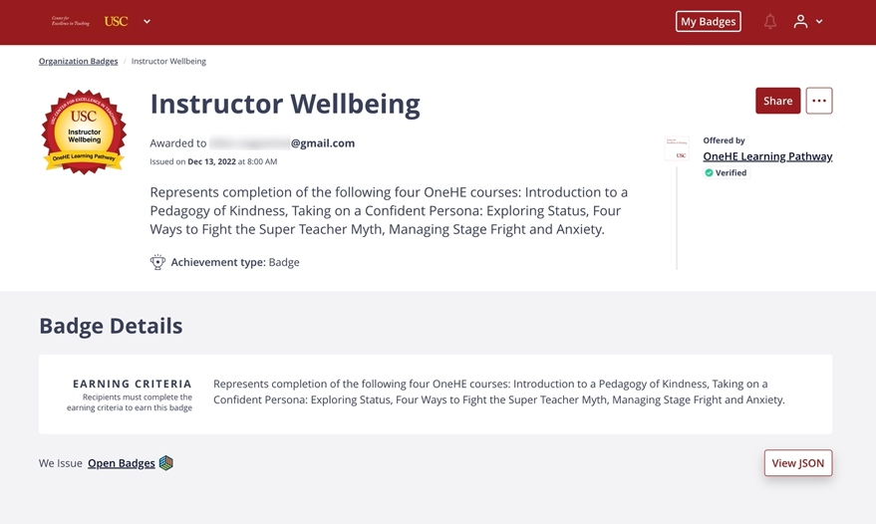

Click the Share button located in the upper right to view your badge sharing options.
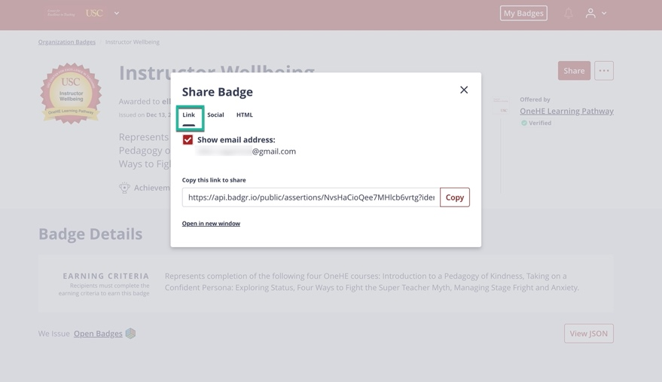

The Share Badge pop-up dialogue box is an option to include or exclude your recipient identifier (Show email address) when sharing your badge. If you check the box to include the recipient identifier, your email address will be included with the badge when it is shared. If you uncheck the box, the recipient identifier will be excluded (your email address is not shared) on the page that displays your badge award.
The next field in the box (Copy this link to share) allows you to copy a link, which can be used to share your badge directly with anyone who has the link. This will also allow you to create a hyperlink with your badge image in an email signature line or document.
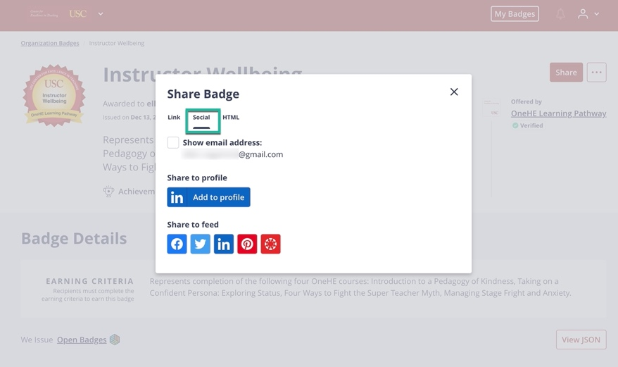

The tab immediately next to the link tab is labeled social. Selecting this tab will display a number of social media badge sharing options. You can select to add your achievement to your LinkedIn profile (Share to profile), or select one of the social media buttons and create a post to share your badge with your network (Share to feed).
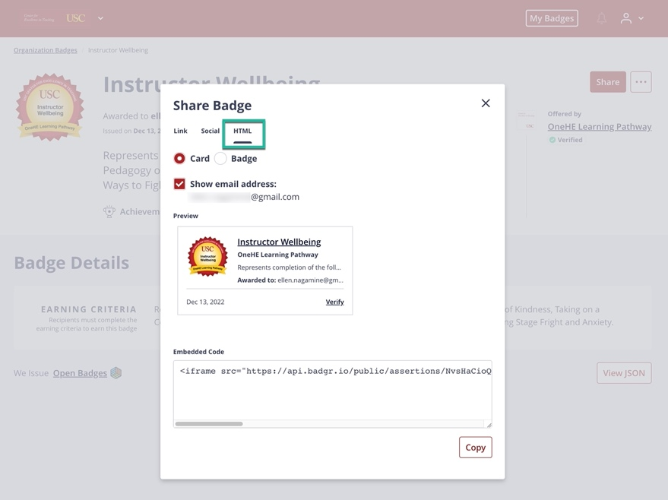

The final tab available in the share feature is titled HTML. This tab lets you embed your badge, either as a card or the badge image with its underlying data, directly in a blog, webpage or digital portfolio.
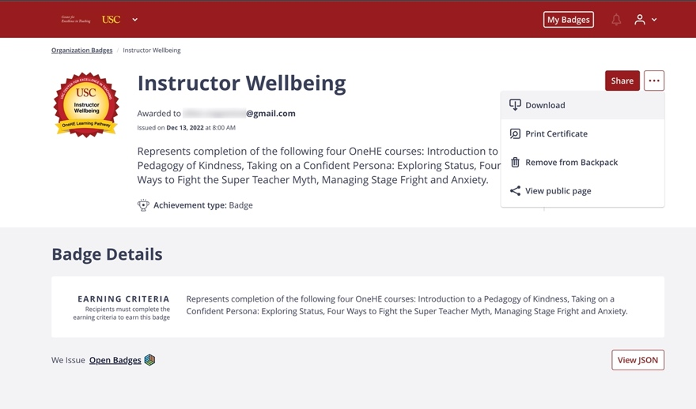

Upon closing the pop-up, you will return to the badge page. The ellipses button in the upper right next to the share button displays several other options for managing
your badge.
- You can download the image file from your badge to your device.
- You can also view and print a certificate of achievement. In addition to displaying the badge image, a QR code is included so viewers can access the badge award page.
- You can view the public page associated with your badge.

