Accessing Independent Review Resources for Online Teaching in Blackboard

What is this resource?
A step-by-step guide to access the Independent Review Resources for Online Teaching in Blackboard. There are three organizations available, depending on your USC role.
- Independent Review Resources for Faculty Teaching Online
- Independent Review Resources for Teaching Online for Staff*
- Independent Review Resources for Teaching Online for TAs

How do I use it?
Review the steps. If you do not see the organization listed In Blackboard and wish to be enrolled, please complete this form. If you have questions, contact the CET Office at usccet@usc.edu.
*Staff need to request enrollment in the Independent Review Resources for Teaching Online for Staff.

Accessing the Independent Review Resources for Online Teaching
- To access Blackboard, log in at blackboard.usc.edu using your USC NetID and password.
- On the home page, you will see your list of courses, and below My Organizations.
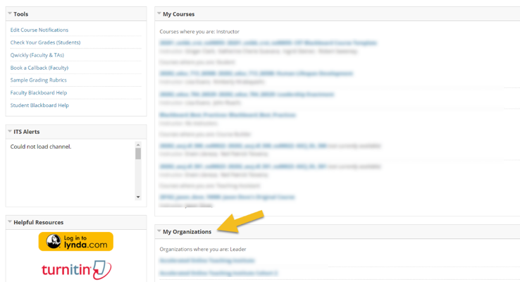
- Under My Organizations, you will see the Independent Review, in which you are enrolled, based on your USC role. If you do not see the appropriate organization listed, please complete this form.
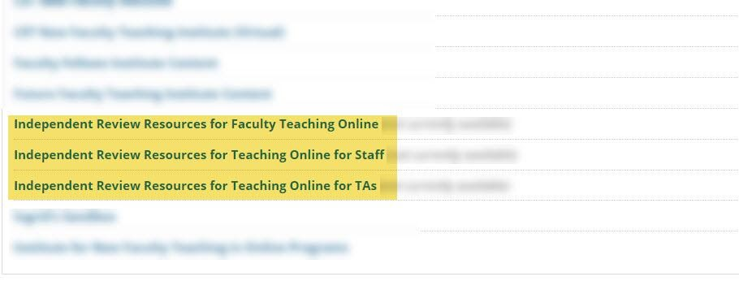
- After selecting the organization title, you will be taken to the Blackboard announcement page and course menu (on the left).
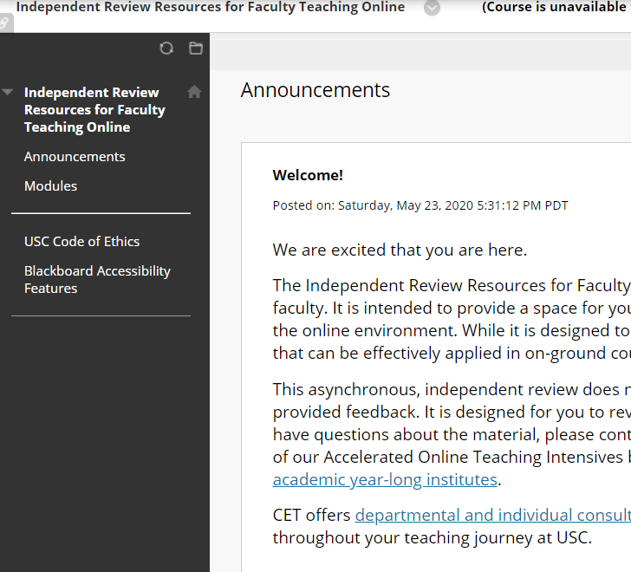
- To be taken to the content, select Modules (1) from the Blackboard course menu. Then, based on your interest, select the appropriate course module (2).
