Designing reflection assessments

WHAT IS THIS RESOURCE?
A description of a five-step model that instructors can use in designing in-class reflective assignments.

HOW DO I USE IT?
To implement a reflective assignment in your course, follow the steps in the model, adapting each to fit your discipline and course topic. You may wish to model your assignment on the examples provided. For assistance, please contact CET.
“Reflection” has diverse meanings, both academic and colloquial, and even academic reflection can take several forms. This document addresses one form of academic reflection. While students may be familiar with reflection in general, they must be taught how to perform reflection in the manner expected by their instructor. This process typically involves modeling by the instructor and guided practice with the instructor before the student works on an independent reflection assignment.
Reflection activities promote metacognition, a powerful tool for learning that requires students to examine their own thinking processes. Reflection activities can be incorporated into any course, in any discipline, and can become highly motivational and engaging for students.
Careful design of reflection assignments ensures that the assignment does not elicit mere opinion. While there are no universally recognized best practices for the design of reflection assignments, many helpful models do exist. Fortunately, the available models share many attributes, which have been condensed into the model presented below.

Academic reflection: a five-step process
Table 1 Academic reflection: a five step process
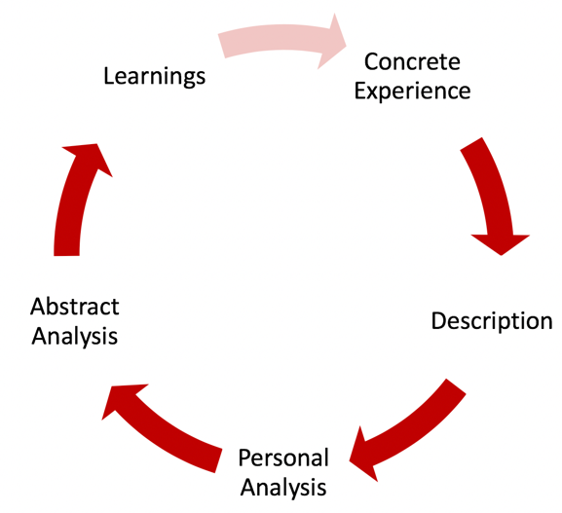
The academic reflection process can be summarized in five steps:
- Concrete Experience – Student completes an experience, usually specified by the instructor, such as a course project, assignment, community event, or past experience.
- Description – Student describes their experience in an objective manner. This description may include the context of the experience, a short narrative of the experience, the persons involved, the intended goals of the experience, etc.
- Personal Analysis – Student details their individual reaction, such as their feelings before, during, and after the experience; their assumptions going into the experience; their thought processes regarding the experience; and anything that surprised them.
- Abstract Analysis – Student explores the experience from outside their own personal perspective, which typically involves an academic perspective and/or a civic-engagement perspective. This is often the section of an academic reflection that explicitly includes references to course topics and materials.
- Academic – principles/models/theories relevant to, or demonstrated by, the experience; techniques/processes/algorithms used in the experience; reasoning used to complete a task; important data that was available or missing; a hypothesis that explains the experience; etc.
- Civic-engagement – impact on individuals and/or the community; perspectives that may be held by others involved in, or affected by, the experience; influence of power and privilege; identification of persons or populations benefitted or disadvantaged; etc.
- Learnings – Student describes what they have learned from the experience and proposes how they could improve the experience or their performance in the future. If applicable, student plans their next experience, incorporating what they have learned.
- Experimentation– In some cases, the student completes their next experience, by implementing the suggestions they proposed in Step 5: Articulate Learning. This experimentation becomes Step 1: Concrete Experience, above, in an iterative cycle of improvement if desired.
To illustrate the application of this model to diverse disciplines, summaries of reflective assignments are included on the following pages.
Sample rubrics, including for academic reflection assignments, are available in the CET Course Design Resources.

Design
Concrete Experience: Student teams will build a bridge using provided materials that spans a 1m gap and supports a 15kg mass in the center of the gap. Each team must provide calculations of the stress on each bridge member. Additional details are provided.
Description: Students objectively describe the experience of working in their team designing, building, and testing the bridge.
Personal Analysis: Students respond to specific questions. Note: Question prompts are important guidance for students who are learning to produce academic reflections
- How well did you feel the team worked together?
- What was the hardest part of the project for you?
Abstract Analysis: Students respond to specific questions
- List the failed attempts and what was learned from each that led to the final design
- Explain the thought process that led to the selected truss design
- Which course principles, if any, did you better understand as a result of the project?
Learnings: Students propose changes that could have made their team more successful and/or efficient, if they were to attempt it again. Students explain how what they learned can be transferred to their future professional practice.

Arts
Concrete Experience: Students produce a creative product, which is critiqued by their classmates following a structured critique protocol. Additional details are provided.
Description: Students objectively describe their creative product and the critique session.
Personal Analysis: Students respond to specific questions
- How did you feel while being critiqued?
- Which critiques most impacted you, and why?
Abstract Analysis: Students respond to specific questions
- Which design or performance principles were most relevant to the critiques?
- What perspectives were expressed by critics that you had not previously considered?
- How might other populations, not represented by those who critiqued your creative product, respond to your work?
Learnings: Students propose changes to their creative product that they will implement before the next round of critique.
Experimentation: Students produce a new version of their creative product, which is then critiqued by their classmates, resulting in an iterative process.

Health care
Concrete Experience: Students treat a client in a clinical setting. Additional details are provided.
Description: Students objectively describe the meeting with their client, including the client’s purpose for the meeting, actions taken, and interpersonal interactions between the student and the client.
Personal Analysis: Students respond to specific questions
- How did you feel before, during, and after the meeting with the client?
- How well do you feel the meeting went?
- What assumptions did you have about the client before the meeting?
Abstract Analysis: Students respond to specific questions
- Which professional skills were most important to your performance?
- What were your performance strengths and weaknesses?
- What knowledge or skills, that you did not have at the time, would have improved the experience for you or the client?
- How did your professional authority impact your interaction with the client?
Learnings: Students propose specific actions they should take before their next client meeting to improve their performance.

Classroom debate
Concrete Experience: Students come prepared to debate a pre-determined topic during class in teams, and the instructor facilitates the debate. Additional details are provided.
Description: Students objectively describe the debate, round-by-round.
Personal Analysis: Students respond to specific questions
- How did you feel while presenting your argument, and while being contradicted by the other team?
- What were team dynamics that strongly influenced your reaction to the experience?
- Abstract Analysis: Students respond to specific questions
- Which arguments and strategies used by your team were strongest, and weakest, against the arguments presented by the other team?
- What procedural aspects made the debate more, or less, productive?
Learnings: Students propose changes to their team’s arguments and strategies to improve their future performance.

Resources
Kolb, D. A. (1984). Experiential learning: Experience as the source of learning and development (Vol. 1). Englewood Cliffs, NJ: Prentice-Hall.
Rodgers, Carol R. (2002). Seeing Student Learning: Teacher Change and the Role of Reflection. Voices inside Schools. Harvard Educational Review, 72(2), 230-53.
The DEAL Model

