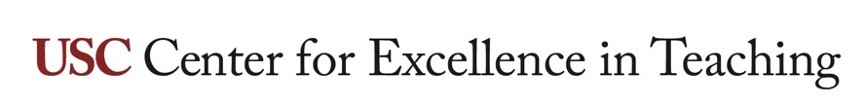

Flipped course design

WHAT IS THIS RESOURCE?
An introduction to the flipped course, a course design style that is more consistent with theories of human learning than traditional lecture-style courses and supported by educational research. The flipped model can be applied to both online and on ground learning experiences.

HOW DO I USE IT?
Before designing a new course, or considering revision of an existing course, review the document. For assistance, please contact CET.

Overview
Flipped courses are “flipped” relative to what can be described as “traditional” courses. In traditional courses, students read the textbook before class, and the instructor lectures to the class while students take notes and perhaps ask questions. After class, students apply the information presented in the lecture in homework assignments. In a flipped course, the content delivery of the lecture is moved to the pre-class work done by students. Instead of lecturing during class, the instructor leads students in active-learning exercises and students engage with the content to develop skills outlined in the course learning objectives. The instructor is then able to provide expert feedback to students in the moment, as they learn.
The function of in-class and out-of-class work are flipped.
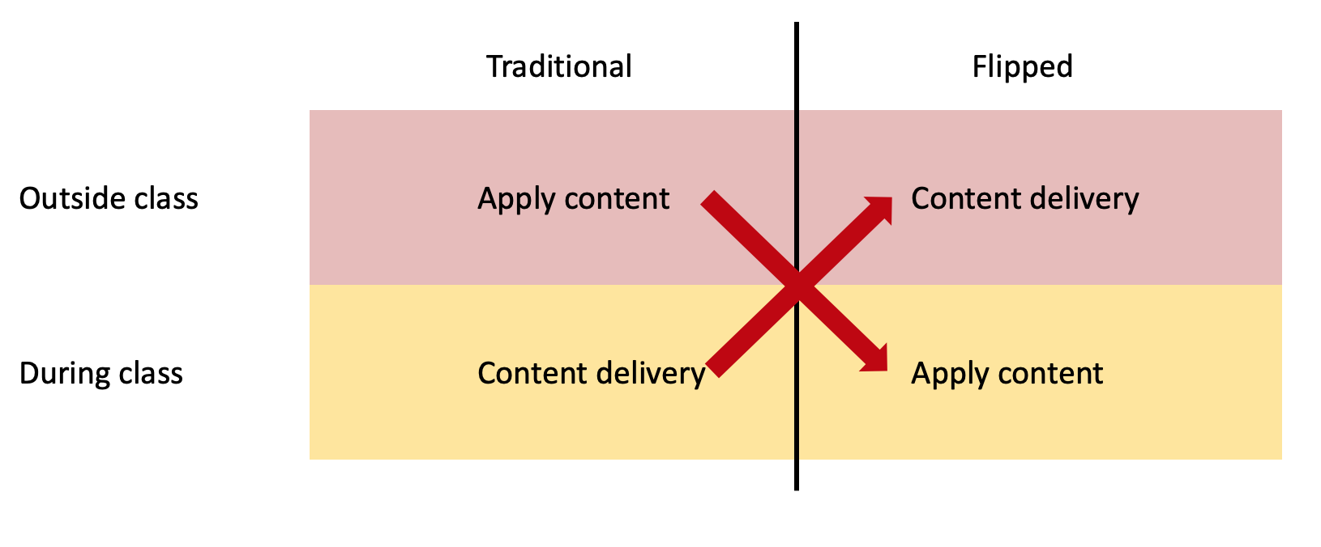

Role of the instructor
One critical difference between typical traditional and flipped courses is the role of the instructor. In the traditional model, the instructor is present with the student during the step of content delivery. In the flipped course, the instructor is present during active learning to guide students through their application of the content, and this becomes a main benefit of the flipped model.
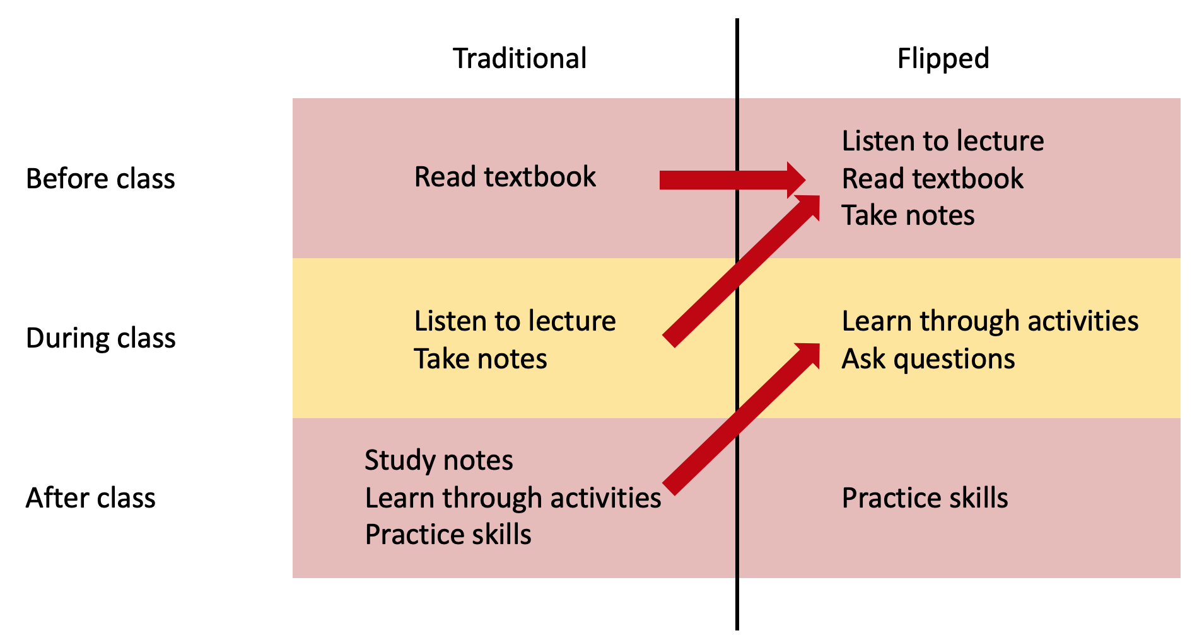We know from theories of human learning that deep learning occurs when learners actively engage with information. During passive learning (listening, reading, watching) learners can gain information, but it is only through active learning that learners embed the new information into their long-term memory and develop new skills. Active learning occurs during application of the new information: testing, applying, arguing, evaluating, creating, explaining, attempting new skills, and learning from errors.
If students are attempting to learn new skills by applying their newly gained information as homework, the student may make mistakes and not realize them. In their out-of-class practice, students can repeat their mistakes, thinking they are correct, and through practice embed incorrect practices into their long-term memory. The instructor then needs to recognize the students’ incorrect practices and help the students un-learn them and re-teach students the correct practices.
In the flipped classroom, students are actively learning in the presence of the instructor, who is there to observe students working, identify students who need correction, and correct their cognitive trajectory before it becomes a learned practice. The flipped classroom is more efficient than the traditional classroom at producing positive student learning (see citations below).

Flipped delivery of information content
Several options are available for providing students course content in a flipped course, as asynchronous resources:

Instructor-created lecture recordings
- Record yourself lecturing during a Zoom session with no students present and share the recording.
- Produce a narrated PowerPoint presentation.
- Use software to record a lecture, such as iMovie, QuickTime, etc.
- Lecture recordings should ideally be no more than 10 minutes long. Longer lectures can be broken up into smaller lectures. Chunking information in this way improves student learning.
- Be sure to provide captions and/or a transcript for accessibility.
- Recorded lectures or other materials should be followed by an asynchronous active learning activity (like a quiz or reflection assignment) to activate long-term memory.

Curated videos
- Links to existing online videos, from common resources (Vimeo, YouTube, etc.)
- Specialized resources (such as video libraries offered by professional organizations.)
- USC Libraries has a guide to streaming media. You can contact a USC Librarian with help locating relevant videos.
- For accessibility, it is recommended that videos are selected that have captions and/or a transcript available.

Text media
- Academic articles (consider using the USC Libraries’ ARES system for providing easy access to students.
- Publicly-available articles from news media, blogs, government sites, commercial sites, magazines, etc. Contact a librarian for help locating resources and copyright clearance.
- For accessibility it is recommended that the text/document is accessible and can be read by a screen reader. Consult with USC Disability Services & Programs https://dsp.usc.edu/

Audio media
- Many free podcasts are available on various topics.
- Keep in mind resources without visual components have been demonstrated to be not as effective as multimedia resources for learning.
- Be sure to have transcripts available for accessibility.

Will students prepare for class?
As with all course requirements, students will review pre-class resources when they find the effort worthwhile. Some tips:
- Only assign resources (videos, articles, etc.) that provide content the student will actually need in the course. Otherwise, students will decide the preparatory work is wasted effort.
- Assign a reasonable amount of pre-class work. Try to be realistic about how much time the work will require of a novice.
- Hold students accountable for the pre-class work.
  - Starting class with activities that require students to recall their pre-class work is often referred to as “activation of prior knowledge.” It helps students prepare mentally for the class.
  - Have a short quiz as part of the pre-class work that requires knowing content from the resources.
  - Have a quiz on the pre-class resources at the start of class.
  - Expect that students will do the work. For example, call on students to summarize assigned articles.
- Don’t lecture during class on resources they should have reviewed before class. This just teaches students not to do the work.

Flipped active learning
The bulk of class time can be spent on active learning, students applying the content they reviewed before class.
- Active learning can be done individually or in small groups. A mix of the two adds variety and interest to a class.
- Instructors can provide short, targeted mini lectures (5-15 minutes) at strategic times in class to help students move forward. This is referred to just-in-time or mini lectures.
- During activities, the instructor migrates among students, monitoring, answering questions, and addressing student misunderstandings.

Supporting evidence
Extensive research demonstrates the effectiveness of active learning, which is facilitated by the flipped-course model.
A review of the literature on the flipped-course model has been prepared by the USC Marshall School of Business.

Flipped course planning examples

Example 1
Pre-class work provided in Blackboard
- Instructor-made lecture recording (10 minutes)
- Short article
- Second instructor-made lecture recording (10 minutes)
- Short Blackboard quiz on main points of previous resources
- Curated YouTube video (15 minutes)
- Discussion forum assignment requiring consideration of reviewed resources. Students are required to critique at least two peers’ posts.
During class
- Welcome and Q & A opportunity (10 minutes)
- Group activity (10 minutes)
- Activity debrief (10 minutes)
- Individual activity (15 minutes)
- Debrief and closing (5 minutes)

Example 2
Pre-class work provided in Blackboard
- Instructor-made lecture recording (10 minutes)
- Second instructor-made lecture recording (10 minutes)
- Blackboard assignment requiring students to explore information in lectures
- Discussion questions to prepare for before class
During class
- Welcome and Q & A opportunity (10 minutes)
- Whole-class discussion (20 minutes)
- Mini lecture expanding on pre-class lecture material (10 minutes)
- Individual activity (5 minutes)
- Debrief and closing (5 minutes)

Example 3
Pre-class work provided in Blackboard
- Required textbook readings
- Curated YouTube video (15 minutes)
- Discussion forum assignment about video content requiring peer comments
During class
- Welcome and Q & A opportunity (10 minutes)
- Pop quiz on pre-class work (5 minutes)
- Extended group activity (25 minutes)
- Students present group findings as debrief (10 minutes)

