Bloom’s Taxonomy

WHAT IS THIS RESOURCE?
An introduction to Bloom’s Taxonomy and its use in designing course learning objectives and assessments.

HOW DO I USE IT?
Refer to the chart when composing course learning objectives and selecting appropriate assessment types. For assistance, please contact CET.

About Bloom’s Taxonomy
Bloom’s taxonomy is a very useful classification model for learning objectives. It was first proposed by Benjamin Bloom in 1956 and slightly revised in 2001.
Bloom’s taxonomy organizes learning objectives according to the type of learning that is being developed. It also has types of learning ranked from low to high, with the lowest level of learning being the recall of facts and basic concepts, and the highest-level being creation of original work. The skills toward the top of the pyramid involve what we call higher-level thinking.
Note that there is no implication that learning at the top of the pyramid is more valid or valuable than at the bottom. In some cases, simple remembering skills are exactly what’s needed in a situation, sometimes it’s creation. It depends on the goals being achieved. Below is a diagram of Bloom’s Taxonomy.
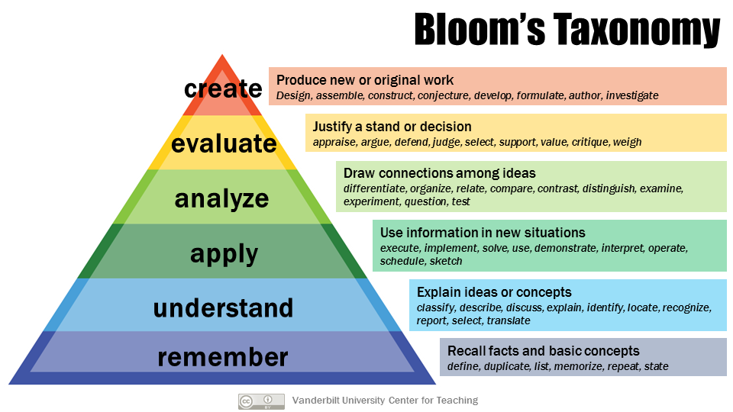
Bloom’s Taxonomy is frequently used in course design. Once the taxonomic level of desired learning is decided, the chart below suggests relevant action verbs that can be used in written learning objectives. The chart also suggests appropriate types of assessments or assignments.

Verbs and assessments for each level of Bloom’s Taxonomy
Table 1 Remember
Action verbs for learning objectives | Action verbs for learning objectives | Action verbs for learning objectives | Appropriate assessment types
Define | State | Enumerate | Fill-in-the-blank
Identify | Quote | Omit | Multiple choice
Describe | Reproduce | Recite | Labeling
Label | Tabulate | Record | Matching
List | Tell | Repeat | Short written response
Match | Copy | Retell | Worksheet
Select | Duplicate | Outline | Workbook
Recall | Arrange | Recognize
Name | Underline | Locate

Table 2 Understand
Action verbs for learning objectives | Action verbs for learning objectives | Action verbs for learning objectives | Appropriate assessment types
Explain | Interpret | Infer | Essay
Describe | Classify | Relate | Exam
Paraphrase | Distinguish | Cite | Problem set
Summarize | Associate | Generalize | Class discussion
Compare | Demonstrate | Rewrite | Concept map
Discuss | Express | Trace | Oral report
Predict | Indicate | Transform | Outline
Convert | Estimate | Group | Story problem
Give examples | Translate | Illustrate | Dramatization
Order |  |  | Debate

Table 3 Apply
Action verbs for learning objectives | Action verbs for learning objectives | Action verbs for learning objectives | Appropriate assessment types
Solve | Experiment | Employ | Problem set
Apply | Dramatize | Explain | Performance
Use | Manipulate | Interview | Lab experiment
Calculate | Paint | Operate | Simulation
Relate | Prepare | Practice | Clinical work
Complete | Act | Predict | Role play
Construct | Administer | Simulate | Demonstration
Produce | Compute | Sketch | Map
Chart | Develop | Discover | Diagram
Collect | Change | Schedule | Prediction
Illustrate | Demonstrate | Write | Model
Modify |  |  | Illustration

Table 4 Analyze
Action verbs for learning objectives | Action verbs for learning objectives | Action verbs for learning objectives | Appropriate assessment types
Analyze | Classify | Advertise | Case study
Compare | Contrast | Conclude | Critique
Infer | Separate | Deduce | Lab experiment
Differentiate | Discriminate | Devise | Essay
Categorize | Divide | Outline | Project
Correlate | Order | Plan | Debate
Diagram | Subdivide | Troubleshoot | Concept map
Organize | Survey | Illustrate | Reflection
Plan | Dissect | Deconstruct | Data analysis
Test | Estimate | Diagram | Spreadsheet
Investigate | interpret | Group | Graph

Table 5 Evaluate
Action verbs for learning objectives | Action verbs for learning objectives | Action verbs for learning objectives | Appropriate assessment types
Critique | Judge | Conclude | Journal
Evaluate | Support | Consider | Diary
Appraise | Discriminate | Debate | Critique
Decide | Assess | Justify | Problem set
Recommend | Measure | Persuade | Product review
Convince | Grade | Appraise | Study
Defend | Rank | Monitor | Peer review
Find errors | Select | Detect | Revision
Score | Rate | Validate | Survey
Argue | Weigh |  | Editorial

Table 6 Create
Action verbs for learning objectives | Action verbs for learning objectives | Action verbs for learning objectives | Appropriate assessment types
Design | Plan | Prepare | Research project
Compose | Write | Assemble | Musical composition
Create | Compile | Collaborate | Performance
Formulate | Construct | Devise | Essay
Hypothesize | Develop | Make | Business plan
Compile | Integrate | Negotiate | Product design
Modify | Organize | Facilitate | Job aid
Rewrite | Structure | Propose | Infographic
Generate | Act | Show | Portfolio
Improve | Arrange | Invent | Poem
Revise |  |  | Advertisement
 |  |  | Video
 |  |  | Blueprint

References:
Blooms Taxonomy Action Verbs (Fresno State University)
200+ Blooms Verbs (www.literacychic.com)
Why should assessments, learning objectives, and instructional strategies be aligned? (Carnegie Mellon University) Eberly Center Teaching Excellence and Educational Innovation
Revised Bloom’s Taxonomy Process Verbs, Assessments, and Questioning Strategies (www.cloud.edu)

