The Zoom raise-hand feature

WHAT IS THIS RESOURCE?
Stepwise instructions for using the raise-hand feature during Zoom sessions.

HOW DO I USE IT?
Refer to this resource when planning to use the raise-hand feature during Zoom sessions. Consider providing this document to students.
The raise hand feature allows students to raise their hand to indicate that they have a question or a contribution to the discussion. You will need to have the latest version of Zoom downloaded to use this function.
- Select Reactions from the Zoom toolbar (ask your students to do the same).
- Students will see the Raise Hand feature when they select this button.
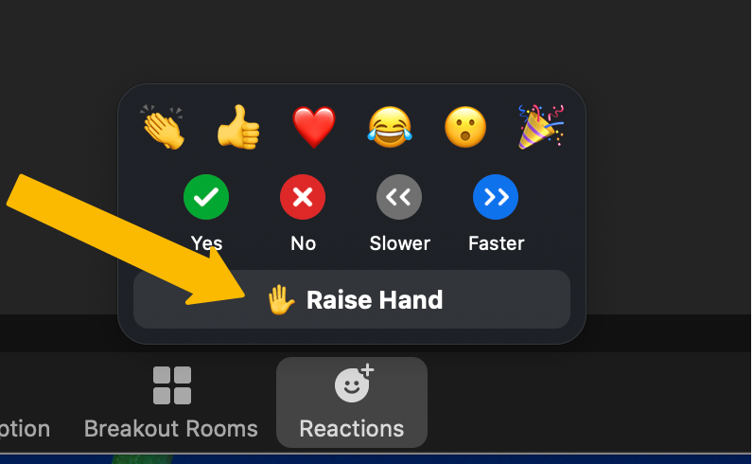
- When a student selects the Raise Hand Icon, you will see a hand appear next to the student name in the participant panel.* You can then call on the student to unmute themselves or you can unmute them. You will also see a hand icon in the upper right-hand corner of the student’s video.
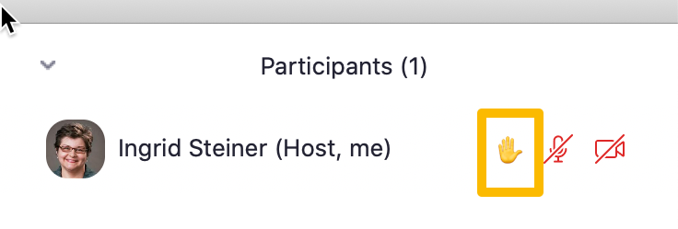
* To open the participants panel, select Participants from the Zoom toolbar.

