Maximize efficiency when teaching large classes

WHAT IS THIS RESOURCE?
A set of tips for instructors who are teaching courses with large enrollments (greater than 30), intended to minimize faculty time requirements and workload while simultaneously maintaining student learning. These tips apply for courses of any delivery type: online, hybrid, or face-to-face.

HOW DO I USE IT?
Before designing or teaching a large-enrollment course, review the recommendations and identify tips that can be incorporated in your course. Alternatively, if facing challenges while teaching a large course, scan the tips for methods of mitigating difficulties. For assistance, please contact CET.

Four lenses of control
We share many concerns about teaching large classes effectively. Certain aspects are out of our control and others within our control. It can help to view the elements we can control in a large class through 4 lenses: policies, groupwork, grading, and feedback. The image below represents the intersection of these four lenses.
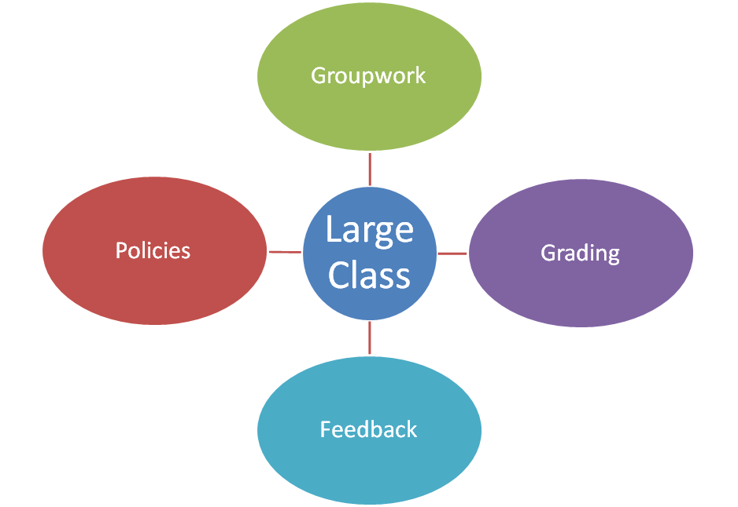

Tips for effectively teaching large classes
The following suggestions are intended to minimize the additional work and time demands that can accompany increased class sizes.

Policies
- Establish a specific student-instructor communication policy including expected response time.
- Set a late work policy with specific deadlines and consequences.
- Create an assignment submission policy wherein student work is submitted electronically through an LMS (learning management system), such as Blackboard.
- Inform students if you follow a cold-calling policy during class time.
- Consider a policy for dropping the lowest grade(s) to avoid an abundance of appeals.
- Change attendance and/or participation to “in-class assignments.” Give minimal points for submitting assignment products as a means of documenting student attendance and active participation.
- Make a welcome video to help create community and review policies in the syllabus.

Groupwork
- Minimize group sizes by making more, smaller groups (up to 4 students each) instead of fewer, larger groups.
- Facilitate structured groupwork with guided instructions and required deliverables.
- Turn what used to be individual assignments into pair/group assignments.
- Choose only select groups to share out rather than every group every time and rotate the groups that are selected to share out.
- Incorporate icebreaker activities to help student working groups bond and establish job roles.

Grading
- Design each assignment prompt to include the related course learning objective, a brief narrative description, numbered steps, and grading rubrics. See the support document Assignment description template available from the CET course design resources web page.
- Provide students with assignment prompts and grading rubrics ahead of due dates.
- Develop grading rubrics specific to each course assignment.
- Upload grading rubrics to the LMS to reduce grading time.
- Test students’ skills with frequent, low-stakes quizzes auto-graded by the LMS.

Feedback
- Keep a running FAQ posted to the LMS where student questions are answered publicly.
- Employ facilitated, structured peer review so students can give each other feedback on assignment drafts.
- Use online discussion board assignments, following a process that respects faculty time restraints. See the support document Manual for online discussion forums available from the CET instruction resources web page.
- Poll students both for formative assessment and to incorporate active learning.

