Live transcription in Zoom

WHAT IS THIS RESOURCE?
Faculty Zoom accounts now have the capability to enable live automatic speech recognition transcription (similar to closed captioning) in real time for meetings and live sessions. As the host of your live classroom sessions, you can enable this feature during each class by following the instructions below. Transcripts can be considered an important part of universal design, supporting students’ various learning, abilities, and environments.

HOW DO I USE IT?
This resource explains how to turn on the live transcription during a Zoom meeting. If you have any questions related to transcription accessibility, contact Kathi Neuenschwander. For information on live transcription in Zoom, please connect with USC Zoom support.

Enabling the live transcript function in your Zoom meeting
1. Navigate to the CC “Live Transcript” icon in your Zoom control toolbar.
2. Select the “Enable Auto-Transcription” option.
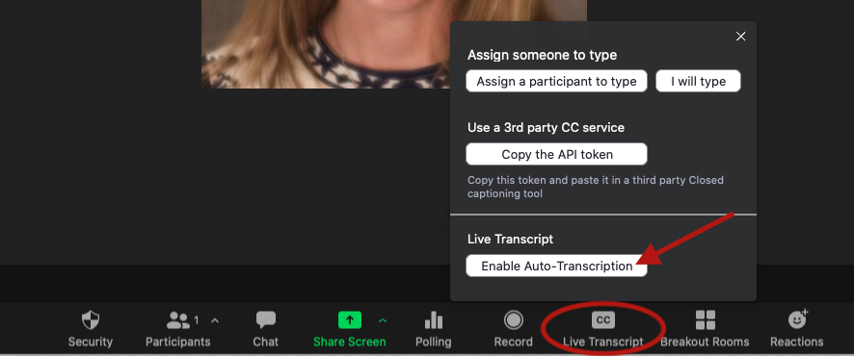
3. Once selected, the auto-transcription feature will be activated, and subtitle captions of live speech will appear at the bottom of the screen.
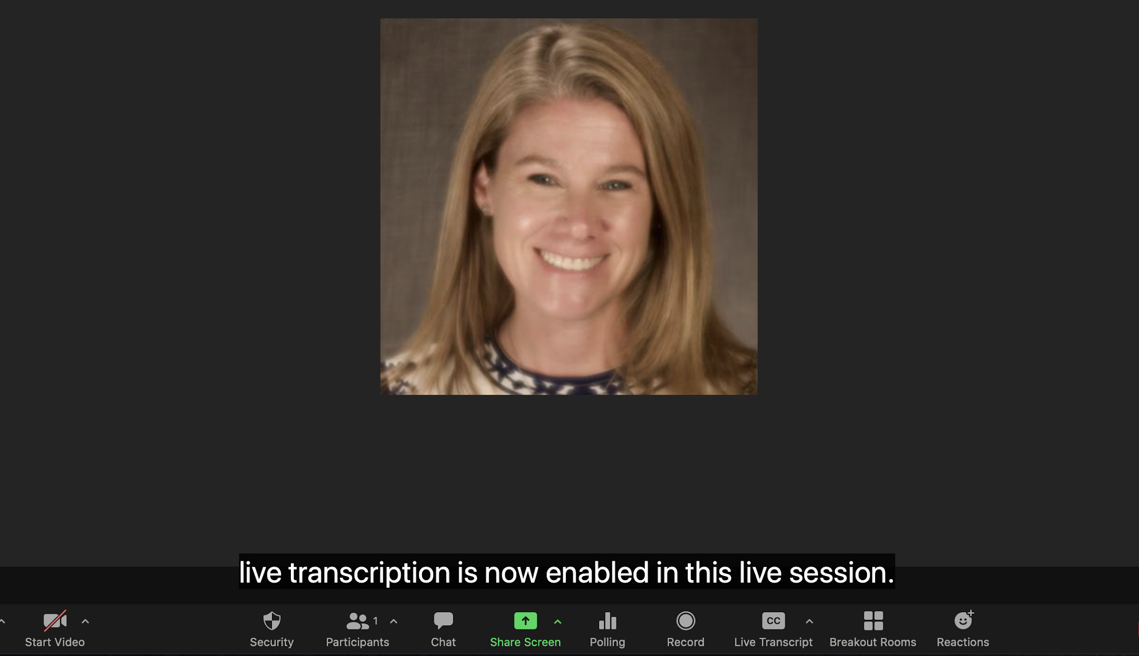

Hiding the subtitle captions during a live session
Individuals in the live session (including the Host) can hide enabled subtitle captions if they wish. To hide the captions, individual participants may select the CC “Live Transcript” option and then select “Hide Subtitle”.
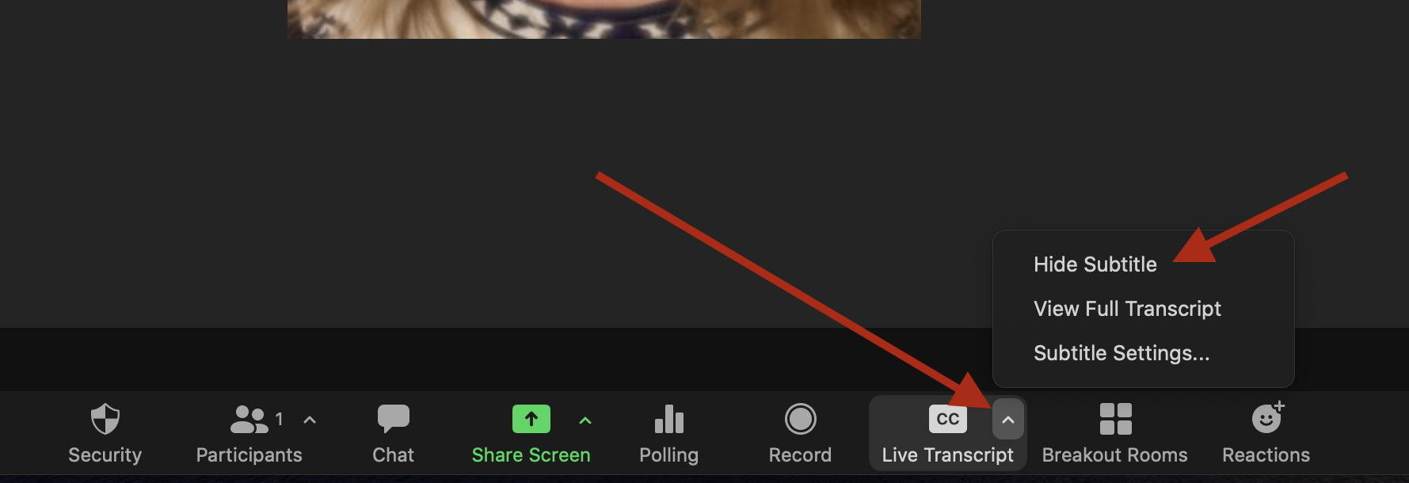

Turning off the live transcript function in your Zoom meeting
1. Navigate to the CC “Live Transcript” icon in your Zoom control toolbar.
2. Select “Disable Auto-Transcription”.
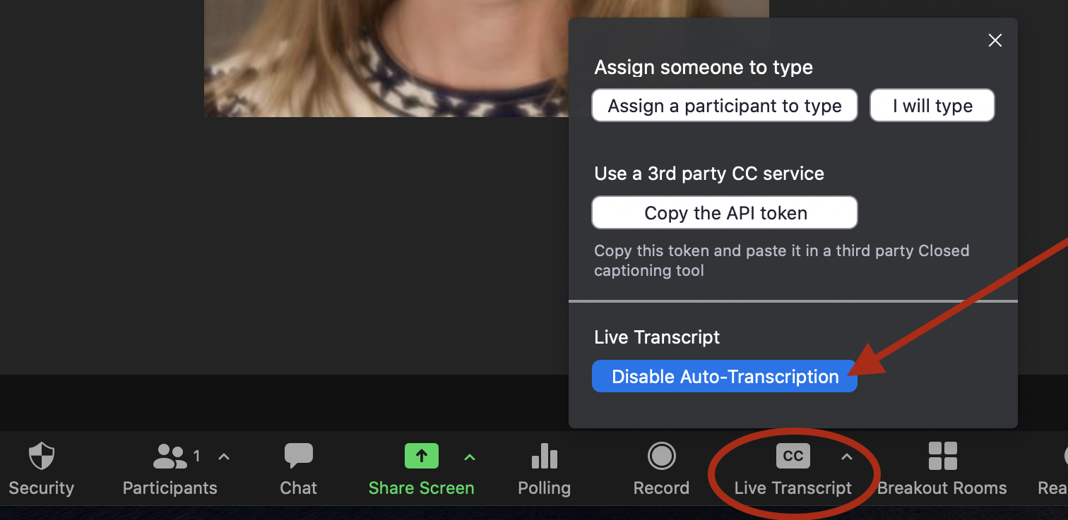

Transcriptions and accessibility
This information pertains to the Disability Services and Programs (DSP) approved accommodation of CART services, also often referred to as “live transcription services,” “live captioning services,” or “real-time captioning services.” These are services that DSP provides for qualified students. Outside CART providers, secured by DSP, provide the same services as Zoom’s live transcription feature, however, they are human-generated, rather than the auto-generated.

Important considerations
- Although Zoom’s live transcription feature will benefit many, there are factors that can impact its accuracy. For example: specialized use of terminology such as medical, engineering, or law classes, speech patterns of the speaker(s), amount of cross-talk, and strength of the audio feed.
- Because 100% accuracy is not guaranteed for all settings, it should not be automatically assumed that Zoom’s feature will satisfy compliance policies and requirements of the disability laws and used as an official accommodation.
- Professors with DSP students with “CART” as an approved accommodation enrolled in their classes, turn on the “live transcription” feature within Zoom.
- For students who have been approved for “CART” services, DSP will continue to provide qualified CART providers to connect with each live class session. If the student observes that Zoom’s transcription feature is effective and accurate, the student will then communicate with DSP and the CART services will be cancelled.
- Do not use Zoom live transcription to serve as subtitles for pre-recorded content such as in-class videos, tutorials, or asynchronous videos. For information on options for captioning your course videos, contact Disability Services and Programs.
Special thanks to USC Bovard College and Disability Services and Programs for contributing to this document.

