in collaboration with
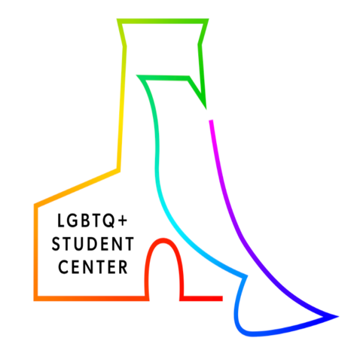

Creating LGBTQ+ inclusive learning environments

WHAT IS THIS RESOURCE?
Fostering an inclusive learning environment is especially important. It gives all students the chance to challenge biases and misconceptions, critically think and respond in a sensitive and productive manner, build supportive and mature interpersonal relationships, succeed academically, and feel a sense of belonging. This resource presents ways to foster a more LGBTQ+ (lesbian, gay, bisexual, transgender, queer, plus) inclusive learning environment, available USC support services, and suggested online resources.

HOW DO I USE IT?
Review this resource and consider how you could incorporate these techniques into your course environment. For additional information on creating inclusive learning environments contact CET. To discuss how to support a student who identifies as LGBTQ+ contact USC’s LGBTQ+ Student Center.

Why create a LGBTQ+ inclusive learning environment?
- Inclusive learning environments support a student’s ability to empathize, connect, and collaborate with a diverse group of peers, and encourages respect for all.
- LGBTQ+ inclusive learning environments support a LGBTQ+ student’s sense of belonging, which has been demonstrated to be positively associated with academic retention/success, improved mental health outcomes, and positive identity development among LGBTQ+ youth.
- LGBTQ+ inclusive curriculum benefits all students by promoting acceptance and respect of the diverse people of the world.
- LGBTQ+ marginalization and exclusion can harm those directly affected and make others fearful to express their identity for fear of disapproval and rejection.

Ways to foster an inclusive LGBTQ+ learning environment

Include an open-ended question in a pre-semester survey or announcement
This gives students the opportunity to share whatever they would like you to know about interacting with them in class and sends a message that you are sensitive to issues about their identities. A possible prompt would be “Please email me privately with anything you would like me to know about your identity, background, or learning needs.”

Model and affirm the usage of pronouns
On the first day of class, use your pronouns in your formal introduction to your class. For example, “My name is Tommy Trojan, and my pronouns are they/them/theirs.” Include “pronouns” as one of the criteria for class introductions. You could say something like, “Please introduce with yourself with your name, pronouns, class year, and major.” Consider adding your pronouns to your contact info on your course syllabus as well as to your email signature. You could also use a “Pronouns & Names” statement in your course syllabus to affirm the rights of your students to be addressed by their pronouns and names in accordance with their gender identity.
Resource: My Pronouns
Resource: USC Office for Equity, Equal Opportunity, and Title IX (EEO-TIX)

Familiarize yourself with terminology
Within the LGBTQ+ community, there are many terminologies that are used to describe a person’s gender expression, gender identity, and sexual orientation/identity. It is not necessarily important to memorize all of these terms, but it is important to respect and affirm how someone identifies. You can do this by avoiding labeling anyone with particular terms unless they self-describe with that identity and are comfortable with you describing them in that way. You should never share someone’s identity unless they have given you permission to do so, and even then, you should consider allowing that person the agency to reveal that information themself. Also, keep in mind that these terms can mean very different things to different people. Depending on the situation, you could ask something like: “What does that identity mean to you?” But you should avoid asking, “How do you identify?” Consider how things you would ask or say would affect you if you were asked them by someone else.
Resource: GLAAD Media Reference Guide (with terminology sections)
Resource: Is it OK to Say “Queer”?

Assess your course content
Incorporate LGBTQ+ history, current events, and people who have contributed to your field into course content and assignments where applicable. Students seeing their identities reflected in course content sends a powerful message that they belong in this class and in the field of study.
Resource: Gender Spectrum Collection
The Gender Spectrum Collection is a stock photo library featuring images of trans and non-binary people. Images from this collection do require credit to be given in your work. Refer to their guidelines page for usage information. No account creation is required.

Assess your own classroom climate
The well-meaning greeting, “Good morning, ladies and gentlemen,” can be perceived as a microaggression as it excludes people who identify outside of the female/male gender binary. Put the pronouns you use on your email signature and syllabi. Doing so signals to students that you are sensitive to identities outside of the gender binary. Correctly refer to students by the pronouns they indicate to you privately or on the class roster. You can also encourage students to indicate their pronouns in Zoom so that they are not misgendered.
To permanently change a Zoom display name to include chosen name and pronouns:
- Login to https://usc.zoom.us/profile
- Click 'Edit' next to your name
- Change your Display Name
- Example: Tommy Trojan (he/him/his)
- Click 'Save Changes'

Be a resource
Learn about the USC LGBTQ+ Student Center (LGBTQ+SC), LGBTQ+ student organizations, other university department programs and services, and LGBTQ+ student issues. At the LGBTQ+SC, there are programs and services offered for students based on the needs of various communities, including the LGBTQ+ Peer Mentoring Program, weekly programs (e.g., Queer Fandom Fanatics, Queer and Trans People of Color (QTPOC) Lounge, First-year Advocacy Board, Rainbow International for LGBTQ+ international students, and the Queer Book Club), and emotional support services (e.g., Trans@SC Office Hours). In addition to our LGBTQ+SC, there are LGBTQ+ specific Counseling and Mental Health services (e.g., the Gender Spectrum and Queer & Questioning support groups and LGBTQ+SC embedded counselors), an LGBTQ+ specific advocate with the Relationship and Sexual Violence Prevention and Services (RSVP), and the Rainbow Floor (a living-learning community for LGBTQ+ students). Feel free to contact the LGBTQ+ Student Center with any questions by emailing lgbt@usc.edu.

Consult institutional data
The USC Well-Being Collective has published a variety of updates and reports highlighting elements of the LGBTQ+ Student Experience. Check out their Special Data Report on the Disparities in Wellbeing among LGBTQ+ Students pulled from findings from the 2020 Student Wellbeing Index Survey or their Data Update on Mental Illness from the 2018 Healthy Minds Study. These reports and others can be found on the USC Well-Being Collective website.

